Goodway Nursery School
Early Years Pupil Premium Report to Governors 11th April 2019
Early Years Pupil Premium was introduced by government to help early years settings close the attainment gap between the most disadvantaged children and their peers. At the end of Reception, fewer children eligible for Free School Meals achieve a “good level of development” (GLD) than children who are not eligible. EYPP provides around £300 per eligible child and is intended to make a difference by having extra targeted strategies for the rate of progress these children make, and by ensuring practitioners focus specifically on these children’s progress.
For more information about whether you are eligible, please click on the following link: https://www.cloudforedu.org.uk/oeypp/birmingham
Identified Needs
26% of our children are eligible for Early Years Pupil Premium

The needs of children eligible for Early Years Pupil Premium were identified through baseline data analysis as mainly in Communication & Language and Personal, Social & Emotional Development.

Research
We considered The Education Endowment Foundation research that outlines which interventions have been found to be most effective in improving outcomes for children.
- Communication and language approaches Average impact +6 months progress
- Earlier starting age Average impact +6 months progress
- Early numeracy approaches Average impact +6 months progress
- Play-based learning Average impact +5 months progress
- Self-regulation strategies Average impact +5 months progress
- Parental engagement Average impact +4 months progress
- Early literacy approaches Average impact +4 months progress
- Digital technology Average impact +4 months progress
- Physical development approaches Average impact +3 months progress
- Social and emotional learning strategies Average impact +3 months progress
- Extra hours Average impact +3 months progress

Summary End Spring Term 2019
 | Attainment |  |  |  |  |  |  |  | Progress
 | Well below age related expectations  8-20 & 16-26 months |  | Below age related expectations  22-36 months |  | Within age related expectations  30-50 months |  | Above age related expectations  40-60 months
 | Attainment on entry | End Term | Attainment on entry | End Term | Attainment on entry | End Term | Attainment on entry | End Term | %  Expected progress or more  (2+ steps) | %  Rapid progress  (3+ steps)
EYPP 28%  Non EYPP | 14  18 | 0  2 | 81  75 | 12  10 | 1  7 | 82  80 | 0  0 | 6  8 | 89%  96% | 89%  95%

Interventions
We use the Early Years Pupil Premium funding to provide targeted interventions:
- Children at risk of language delay: Fortnightly language intervention group to provide targeted support
- Children with EAL: Fortnightly EAL group to provide targeted support
- Children with lower emotional well being: Weekly nurture group to provide targeted support
- More able children: Weekly teacher led phonic extension group
- All eligible children: Weekly Yoga Workshops – working on Listening and attention, Self-regulation & PSED
- All eligible children: Teacher lead project focusing on CL & PSED
- All eligible children: Subsidised trip to the theatre with parents
- All eligible children: Subsidised trip to the farm with parents

EYPP Summary End Spring Term (April 2019)
Attainment:
- On entry 1% were working within age related expectations, (compared to 7% of Non EYPP) 81% were working below age related (22-36 m) (compared to 75% of Non EYPP) and 14% working well below (16-26 m) (compared to 18% of Non EYPP)
- At the end of the Spring term 82% of children eligible for EYPP were working within age related expectations (compared to 1% on entry). 6% were working above (compared to 0% on entry)
12% were working below age related (compared to 81% on entry) and 0% working well below, (compared to 14% on entry)
Progress:
- 89% made expected progress or above (compared to 96% of Non EYPP) and 89% made rapid progress(compared to 95% of Non EYPP)

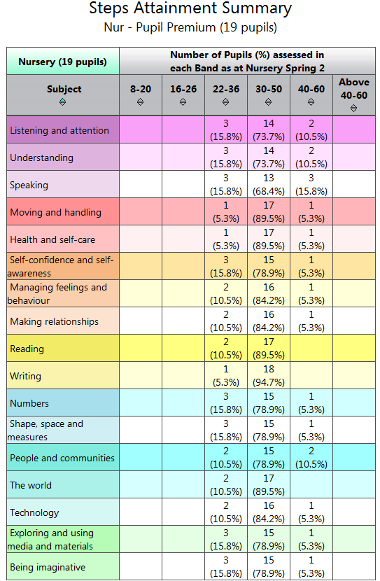
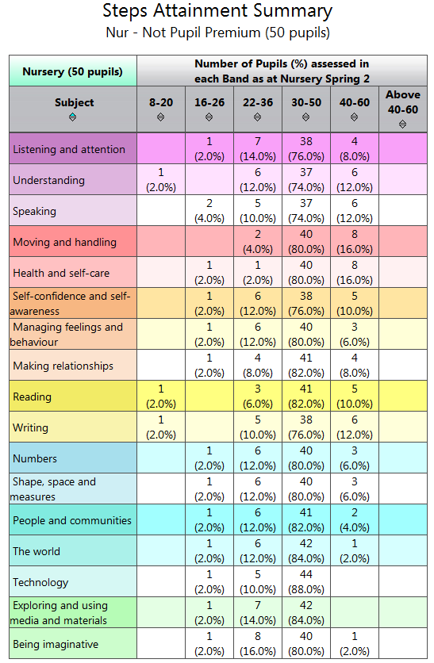

Early Years Pupil Premium 2019-20
Anticipated funding April 2019 – March 2020: £6,900
Early Years Pupil Premium: 23 children @ £300 per child
Early Years Pupil Premium Plus: LAC: 0
Group | Intervention | Expected impact | Cost | Progress End Spring term
Children at risk of language delay | Fortnightly language intervention group to provide targeted support | Children to make accelerated progress in communication and language from their individual starting points | TA cover to enable targeted intervention group  £614 = 1 hour per week | PROGRESS  % Expected progress or rapid (Compared to Non EYPP)  89% (cf 96%) | PROGRESS  % Rapid progress  (Compared to Non EYPP)  89% (cf 95%)
Children with EAL | Fortnightly EAL group to provide targeted support | Children to make accelerated progress in communication and language from their individual starting points | TA cover to enable targeted intervention group  £614 = 1 hour per week
Children with lower emotional well being | Weekly nurture group to provide targeted support | Children to make accelerated progress in personal, social & emotional development from their individual starting points | TA cover to enable targeted intervention group  £614 = 1 hour per week
More able children | Weekly teacher led phonic extension group | Children to make accelerated progress in literacy from their individual starting points | TA cover to enable targeted intervention group  £614 = 1 hour per week
All eligible children | Teacher lead project focusing on CL & PSED | Children to make accelerated progress in communication and language from their individual starting points | TA cover to enable targeted intervention group  £614 = 1 hour per week
All eligible children | Weekly Yoga session | Children to make accelerated progress in communication and language from their individual starting points  Children to make accelerated progress in personal, social & emotional development from their individual starting points | Yoga Bugs x 60 sessions (2 per week) @ £50 per session  £3,000
All eligible children | Subsidised trip to the Theatre with parents | Children broaden their experience of the world and share this with their parents.  Increased parental involvement  Children to make accelerated progress in communication and language from their individual starting points  Children to make accelerated progress in personal, social & emotional development from their individual starting points | £400
All eligible children | Subsidised trip to the farm with parents | Children broaden their experience of the world and share this with their parents.  Increased parental involvement  Children to make accelerated progress in communication and language from their individual starting points  Children to make accelerated progress in personal, social & emotional development from their individual starting points | £400
Total |  |  | £6,870
Early Years Pupil Premium 2018-19
Anticipated funding April 2018 – March 2019: £5,100
Early Years Pupil Premium: 17 children @ £300 per child
Early Years Pupil Premium Plus: LAC:
Group | Intervention | Expected impact | Cost | Progress End Autumn term
Children at risk of language delay | Fortnightly language intervention group to provide targeted support | Children to make accelerated progress in communication and language from their individual starting points | TA cover to enable targeted intervention group  £614 = 1 hour per week | PROGRESS  % Expected progress or rapid (Compared to Non EYPP)  97% (91%) | PROGRESS  % Rapid progress  (Compared to Non EYPP)  99% (94%)
Children with EAL | Fortnightly EAL group to provide targeted support | Children to make accelerated progress in communication and language from their individual starting points
Children with lower emotional well being | Weekly nurture group to provide targeted support | Children to make accelerated progress in personal, social & emotional development from their individual starting points | TA cover to enable targeted intervention group  £614 = 1 hour per week
More able children | Weekly teacher led phonic extension group | Children to make accelerated progress in literacy from their individual starting points | TA cover to enable targeted intervention group  £614 = 1 hour per week
All eligible children | Teacher lead project focusing on CL & PSED | Children to make accelerated progress in communication and language from their individual starting points | TA cover to enable targeted intervention group  £614 = 1 hour per week
All eligible children | Fortnightly Dramatic Artist Workshops | Children to make accelerated progress in communication and language from their individual starting points  Children to make accelerated progress in personal, social & emotional development from their individual starting points | Dramatic Artist Workshops with children  x 30 sessions @ £75 per session  £2250
All eligible children | Subsidised trip to the Theatre with parents | Children broaden their experience of the world and share this with their parents.  Increased parental involvement  Children to make accelerated progress in communication and language from their individual starting points  Children to make accelerated progress in personal, social & emotional development from their individual starting points | £200
All eligible children | Subsidised trip to the farm with parents | Children broaden their experience of the world and share this with their parents.  Increased parental involvement  Children to make accelerated progress in communication and language from their individual starting points  Children to make accelerated progress in personal, social & emotional development from their individual starting points | £200
Total |  |  | £5106
Early Years Pupil Premium 2017-18
Funding April 2017 – March 2018: £6,900
Early Years Pupil Premium: 23 children @ £300 per child Early Years Pupil Premium Plus: LAC:
Group | Intervention | Expected impact | Cost | Progress End Summer term
Children at risk of language delay | Weekly language intervention group to provide targeted support | Children to make accelerated progress in communication and language from their individual starting points | TA cover to enable targeted intervention group  £614 = 1 hour per week | PROGRESS  % Expected progress or rapid of 3 steps or more  (Compared to Non EYPP)  100% (97%) | PROGRESS  % Rapid progress of more than 3 steps  (Compared to Non EYPP)  86% (86%)
Children with lower emotional well being | Weekly nurture group to provide targeted support | Children to make accelerated progress in personal, social & emotional development from their individual starting points | TA cover to enable targeted intervention group  £614 = 1 hour per week
More able children | Weekly teacher led phonic extension group | Children to make accelerated progress in literacy from their individual starting points | TA cover to enable targeted intervention group  £614 = 1 hour per week
All eligible children | Teacher lead project focusing on CL & PSED | Children to make accelerated progress in communication and language from their individual starting points | TA cover to enable targeted intervention group  £614 = 1 hour per week
All eligible children | Focussed support from Key person during Forest School sessions | Children improve self-confidence, language, social skills, risk assessment and experience of the natural world Children to make accelerated progress in communication and language from their individual starting points  Children to make accelerated progress in personal, social & emotional development from their individual starting points | TA cover to enable targeted intervention group  £614 = 1 hour per week  (Total = £3,070)
All eligible children | Fortnightly Ceramic Artist Workshops | Children to make accelerated progress in communication and language from their individual starting points  Children to make accelerated progress in personal, social & emotional development from their individual starting points | Ceramic Artist Workshops with children  x 30 sessions @ £180 per session  £2,400
All eligible children | Subsidised trip to the Theatre with parents | Children broaden their experience of the world and share this with their parents.  Increased parental involvement  Children to make accelerated progress in communication and language from their individual starting points  Children to make accelerated progress in personal, social & emotional development from their individual starting points | £600
All eligible children | Subsidised trip to the farm with parents | Children broaden their experience of the world and share this with their parents.  Increased parental involvement  Children to make accelerated progress in communication and language from their individual starting points  Children to make accelerated progress in personal, social & emotional development from their individual starting points | £600
Total |  |  | £6,670

