

**Early Writing**

**Little children’s mark making and drawings are their way of communicating and sharing observation of their world. The adult’s role is to encourage, praise and celebrate their achievements.**

Children will imitate adults, grasping writing tools and making marks on paper or any surface that is available!

These early marks need to be nurtured and guided in order to develop a confident and evolving hand as they form the basis for the handwriting which will develop.

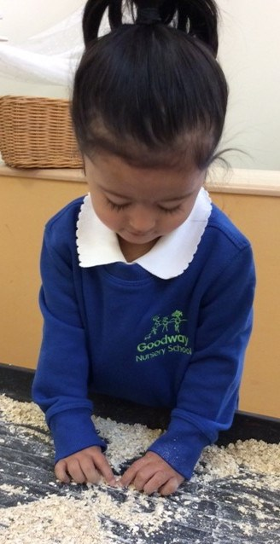

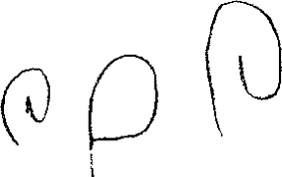

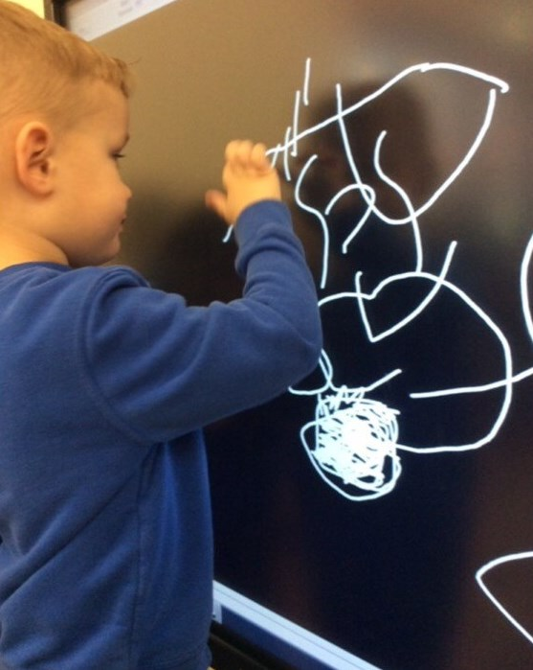

**Mark Making and Writing**

Writing should be seen as an enjoyable fun experience. Developing a child’s mark making skills in the early years will allow them to learn to control a pencil in such a way that it becomes automatic. In so doing 100% of their attention can shift to generating text!

Learning to hold a pencil and make marks that ultimately lead to writing is a complex development. Children move through stages in their mark making. In the early stages it is a physical activity. The child grasps tools with their whole hand in a palmar grip moving their arm from the shoulder. The first recognisable objects are usually human figures.

Gradually muscle control becomes more defined. Features are added to figures such as arms (often projecting from the head) then a body, fingers, toes, clothes and hair.

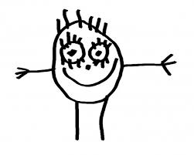

**Stages of early mark making**

* Initially children form lines and dots
* They then develop the ability to imitate a directional mark made by others
* Gradually curves and enclosures emerge (enclosures made anticlockwise are a pre-requisite for forming letters)
* Children then develop the ability to copy straight lines and curves made by others
* Finally they develop the ability to use straight lines and curves to form symbols

Developing the pencil grip, referred to as a tripod grip, also takes time. Children need to develop the strength in their hands, fingers and wrists. They need to be able to move their fingers separately, to use a pincer grip (using their thumb and index finger). Their wrists and thumb need to be strong. Finally they need to learn to rest their wrist on a table and to use their non-dominant hand to hold the paper still. To execute successful writing the side of the hand needs to slide along the paper

**Activities to encourage pencil grip and rotation**

These activities are fun, play activities but have a direct effect upon developing perception, control and sensory experiences. There are many other activities that offer similar opportunities

* Play dough - pinching, squeezing, with thumb and forefinger, poking, rolling to make a snake
* Threading - beads, pasta straws, make necklaces
* Picking up small objects using the thumb and index finger, learning to use tweezers and pipettes or small eye droppers. Count dried peas into a pot or post pennies into a money box or use inset puzzles.
* Finger rhymes - stretching and curling fingers, moving them independently
* Water play - using spray toys and spray bottles. Water the flowers, spray the path or windows
* Craft activities - glue sticks and paint brushes. Making collages with paper, decorating with sequins.
* Icing cakes - using a plastic dispenser to push and squeeze out the icing.
* Strengthening activities - swinging from a climbing frame, grasping to climb, crawling through tunnels.
* Stirring cake mixtures - using a two handed operation, one to hold the bowl the other to stir. Encourage anti-clockwise rotation
* Making powder paint and blending colours– as with mixing a cake.

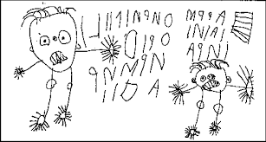

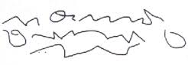

**Activities to encourage Mark Making**

This should go beyond pencil and paper and include a range of textures and media

* Paint using an easel and large brushes
* Paint the paving stones/ flags with water
* Draw shapes in the air with a wand
* Dance with a ribbon in your writing hand
* Chalk on boards or dark coloured sugar paper
* Draw in the sand
* Finger paint on the table with cold water paste and powder paints
* Make rubbings on rough surfaces
* Draw in cornflour ‘slime’
* Make a tactile display with objects and materials that the child can change or move.
* Use tactile natural materials for example wood, suede, hessian, fur, twigs, shells, moss, leaves, flowers, pebbles, feathers etc

