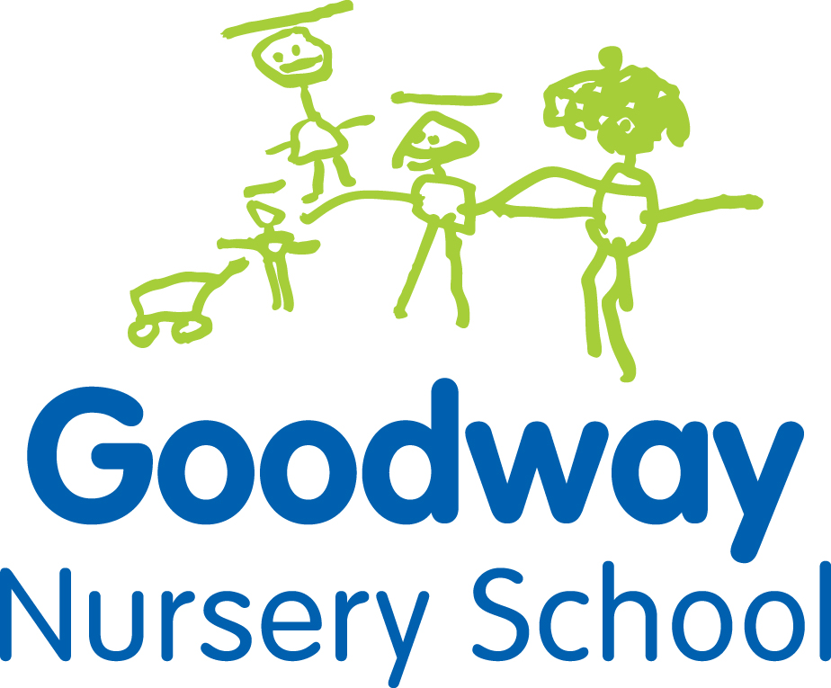
Goodway Nursery School Application Form
Child’s full name: ………………………………………………………………………
Date of birth: ……………………………………………………………………..
Gender: …………………………………………………………………….
Parent/carer name: ……………………………………………………………………..
Address: ……………………………………………………………………………..
……………………………………………………………………………..
Post code: …………………………………………………………………………….
Home telephone: …………………………………………………………………………..
Mobile telephone: …………………………………………………………………………
Siblings attended Goodway (Y/N) Key Person…………………………………….
Special Educational Need or Disability?...........................................................

Place required:
2-3 year old provision Eligibility Checker Reference Number ………………………….

Morning place 8.45am – 11.45am

or Afternoon place 12.30pm – 3.30pm

Fee paying place (£80 for each 15 hours all mornings or afternoons)
3-4 year old provision

Free Part Time places (15 hours): Mon Tue Wed am

or Wed pm Thurs Fri

Fee paying place (£85 for 15 hours)

Free 30 hour place Many working parents are eligible for a free 30 hour place for their child
Please complete the attached form if you think that your child meets the criteria
Parent/carer signature: ………………………………………
Staff signature: ………………………………………….
Date of application: …………………………………………………………………….

PLEASE SEE OVERLEAF FOR CRITERIA FOR 30 HOUR PLACES & TWO YEAR OLD PLACES
30 HOUR FREE CHILDCARE CRITERIA 3-4 YEAR OLDS

From September 2017 working parents of 3 and 4 year olds may be entitled to 30 hours of free childcare, rather than the current 15 hours.
The 30 hours free childcare is only for 38 weeks of the year, not 48 weeks. This is equivalent to school term times.
The eligibility for the 30 hour free childcare is:
- Your child will have their 3rd birthday between 1st September 2017 and the 31st August 2018
- Both parents must be working – or if you are a single parent, then you must be working.
- Each parent earns, on average, a weekly minimum equivalent to 16 hours at National Minimum Wage or National Living Wage.
- Parents must have an annual income of less than £100,000.
- You live in England.
If one parent of the couple isn’t working, or both parents are not working then the family will still be eligible for their free 15 hours. However if one parent isn’t working because they are an official carer (e.g. receiving benefits relating to being a carer) or they are receiving disability benefits, and the other parent is working, the government has stated it “intends to make provision“ to support these families.
You will also be eligible if you are self-employed or on a zero hour contract, as long as you earn at least the equivalent of 16 hours at the National Minimum Wage.
If you think you may be entitled to the free 30 hours then please complete the 30 hours application form attached and return it to Goodway Nursery School as soon as possible, so that we can reserve your free 30 hours from September 2017.
2 YEAR OLD 15 HOURS OF EARLY EDUCATION CRITERIA

15 hours of Early Education for 2 year olds is available to children whose families meet one of the following thresholds:
- Universal credit
- Income support
- Income-based Job Seekers' Allowance
- Income-related Employment and Support Allowance (If you are unable to work due to illness or a disability)
- Support under Part VI of the Immigration and Asylum Act 1999
- The Guarantee element of the State Pension Credit; or Child Tax Credit, provided they have an annual gross income of no more than £16,190 as assessed by Her Majesty’s Revenue and Customs (HMRC).
- Working Tax Credits (including those in receipt during the four-week period immediately after their employment ceases, or after they start to work fewer than 16 hours per week) with a household income of less than £16,190 as assessed by HMRC.
- The child has a current statement of special educational needs or an Education, health and Care plan.
- The child is in receipt of the Disability Living Allowance.
- The child is looked after by their local authority (LAC)
- The child has left care through special guardianship or an adoption or residence order

FEE PAYING PLACES

- This can be used to ‘Top up’ a part time 15 hour place to create a Full time place.
- 3-4 year old place £85 per 15 hours
- 2-3 year old place £80 for 15 hours

