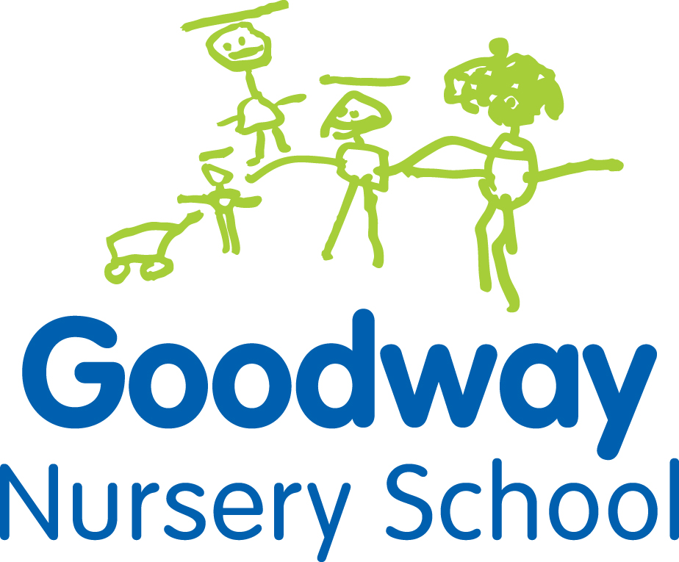
Goodway Nursery School Application Form
Child’s full name: ………………………………………………………………………
Date of birth: ……………………………………………………………………..
Gender: …………………………………………………………………….
Parent/carer name: ……………………………………………………………………..
Address: ……………………………………………………………………………..
Post code: …………………………………………………………………………….
Mobile telephone: …………………………………………………………………………
Siblings attended Goodway (Y/N) Key Person…………………………………….
Special Educational Need or Disability?...........................................................

Place required:
2-3 year old provision Eligibility Checker Reference Number ………………………….

Morning place 8.45am – 11.45am

or Afternoon place 12.30pm – 3.30pm

Fee paying place (£80 for each 15 hours all mornings or afternoons)
3-4 year old provision

Free Part Time places (15 hours): Mon Tue Wed am

or Wed pm Thurs Fri

Fee paying place (£85 for 15 hours)

Free 30 hour place Many working parents are eligible for a free 30 hour place for their child

I give permission for Goodway Nursery to send literature for marketing purposes
Parent/carer signature: ………………………………………
Staff signature: ………………………………………….
Date of application: …………………………………………………………………….

The information you give will be processed electronically and stored on computer for administrative purposes in accordance with the General Data Protection Regulation (GDPR) 2018 Article 6 ‘Lawfulness of processing’ and Article 9 ‘Processing of special categories of personal’ . Please visit our website or call the school office on 0121 464 3078 for further information about how your data will be processed in accordance with our Privacy Notice.

