**Learning Outdoors**

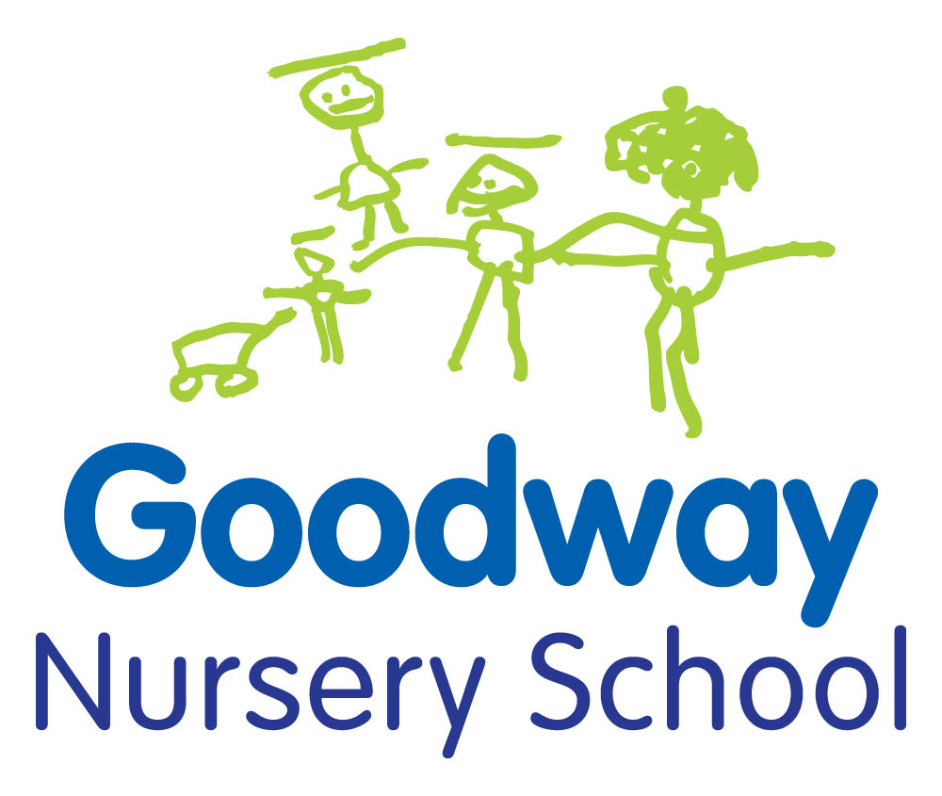

Learning outdoors has a positive impact on children's sense of well-being and development.

Living in a city where many children have limited access to outdoor space, the outdoors provides an important opportunity for children to take risks, to learn from their own first hand experiences and to develop a ‘have a go’ attitude.

The outdoor environment offers space and is particularly important to children who learn best through active movement.

Children access the outdoor learning environment throughout the day at nursery, offering opportunities for physical activity, freedom and movement.

There are lots of activities you can do together to help your child learn outdoors.

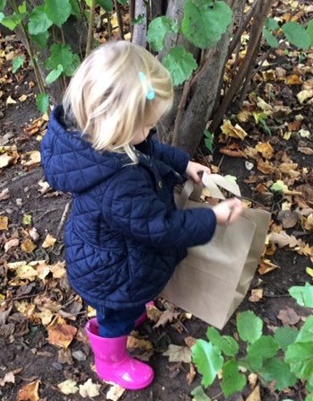

**Lovely leaves!**

As the leaves fall and cover the ground it’s the perfect time to go out and play. Try and find a hill to roll down and see who can get the most leaves stuck to them!

Scoop up the leaves and let them fall, throw them or kick them, how far can you make them travel?

Make a big pile of leaves to jump in or cover yourself in leaves and hide before jumping out and giving everyone a fright!

Cut a strip of card (the outer edge of a cereal box works well) long enough to fit around your head. Use sellotape to join both end together. Look for some lovely leaves to stickonto your card with the tape and make a beautiful leaf crown

How many colours can you find?

**Fly a kite!**

You can make a really simple kite with some household materials such as bin bags and bamboo barbeque skewers

You can find instructions on <http://www.my-best-kite.com/kite-for-kids.html>.

On a nice windy day have a go flying your kite.

It takes a bit of practice and you have to run really fast!

Watch your kite fly up into the air. How high will yours go?

For a quick and simple alternative just tie some string to the handles of a carrier bag and hold on tight

Decorate your kite with paint and markers to add some colour and make your kite unique

Don’t worry if you can’t get it to fly straight away just try again another day it’s still fun to run and pull it along behind you!

**Bird Feeders**

Gather some pinecones, lard, birdseed and string. Using your fingers push the lard into the spaces around the pinecone. Then sprinkle some seeds on top and squeeze them down so they stick!

Next tie some string to the top of the pinecone and hang it from your favourite tree.

Keep watching to see if any birds come and visit or check back in a few days to see if the seeds have gone!

Use gloves if you don’t want your hands to get messy and keep some baby wipes nearby for cleaning sticky fingers afterwards

Make some breakfast feeders for your feathered friends using cheerios threaded onto pipecleaners and hang them up too.

Remember to keep feeding you visitors they will come to rely on the food source especially during the winter.

**Natural Art**

Go for a walk to your local park, woodland or field to find some natural materials i.e. flowers, leaves, twigs and cones.

Stick your materials to a piece of card (you could cut one of the sides from a cereal box) using sellotape or glue.

Take your picture home and find a nice place to display it. You can do this each month to replace the materials as they naturally decay.

Try this in different seasons to explore how the natural materials change and find out what grows at different times of the year

Frame your masterpiece by using sticks and string to make a rectangular shape and create a border to go around the outside of your picture!

**Bug Hunt**

Take out your magnifying glass (you can buy them at the pound shop) and go for a walk to your local area to see what you can find.

Look around in all the places they could be hiding. Check under leaves and in flowers to look for caterpillars and butterflies having their lunch. What else can you find?

Try under rocks or logs on the ground and peeling back the bark on trees to see if there are any insects hiding underneath.

Take a spoon and a small tub if you don’t want to touch them so you can scoop them up (gently!) and have a closer look

Make a mini home for your minibeasts using a bundle of hollow bamboo canes (again from the pound shop) tied together with some string and hung up out of the wind and rain (i.e. on a tree, railing on a balcony etc)

**Floating Boats**

Use a juice or milk carton to make your boat and stick on a straw for the mast and add some card for the sail

You can decorate your boat with different colours and symbols to create your own design such as a pirate ship

Set sail in a nearby river, stream or even a big puddle! Don’t forget to tie on some string so you don’t lose it on the high tides!

Experiment with different materials to see what works best, aluminium takeaway containers float well and you could try fabric for the sail and a wooden skewer for the mast, with clay to hold it in place. Have a go with other household items too!

**REMEMBER - Always supervise children when near water to prevent accidents**

**Woodland Trust**

There is a wide range of excellent activities to carry out with your child at home which you can access through the Woodland Trust website:

www.woodlandtrust.org.uk

**Fun in Puddles!**

Add some washing up liquid to a puddle and make some bubbles as you splash the water with your hands (or feet!)

Pour in some food colouring and watch as the puddles magically change colour. You can use a stick to mix them together and create new colours. Can you make all the colours of the rainbow?

Find a big puddle or make your own and collect some rainwater to fill up an area which will hold the water. Jump in and make a big splash!

See who can get all the water out of the puddle!

Use a ruler and a marker pen to draw measurements on the back of your wellies. Then you can find out how deep each puddle is by walking through it!

Use a bucket and spade to see if you can move the puddle from one area to another

Experiment with putting natural objects in the puddle to find out if they sink or float

