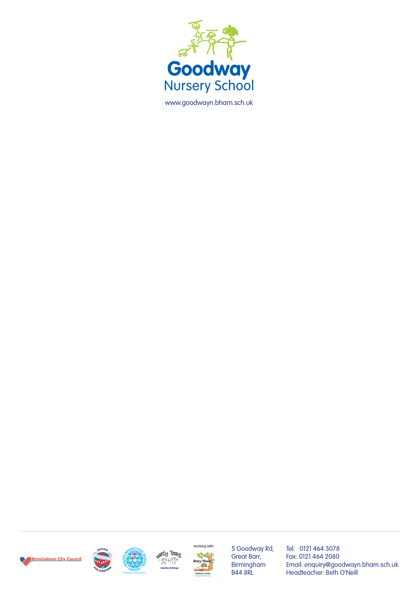

Friday 16th February 2018

Dear Parents and carers,

Have a look at our beautiful new website where you can find out all about our nursery school:

www.goodwayn.bham.sch.uk

You can access newsletters, letters and the school calendar and take a virtual tour of the school.

There are links to Tapestry, Facebook, Startwell and other useful links.

There are lots of photos in the gallery section and you can read about our policies and procedures.

We will be launching our school App after half term so watch this space! It will be compatible with all android and iphones. This will allow you to keep up to date instantly about school events.

We would love to hear your feedback about it, so please let us know what you think.

We would like to welcome Inez back after half term, she has been missed by all children and staff.

Wishing you a lovely half term break.

Best wishes,

Beth