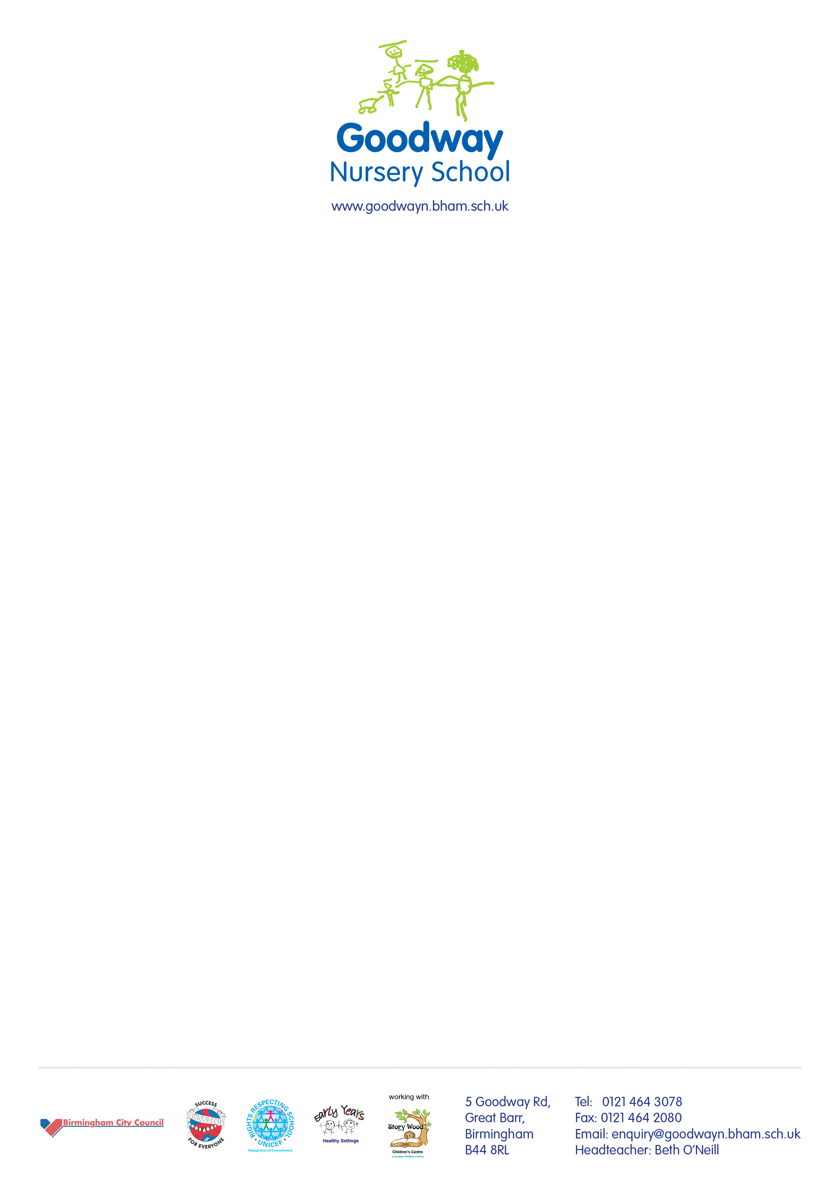

2nd October 2017

Dear Parents/Carers

We would like to kindly request any spare clothes you may have at home which reflect your cultural background. This will enable the children’s development and learning through play and dressing up.

Thank you.

Beth O’Neill

Head Teacher