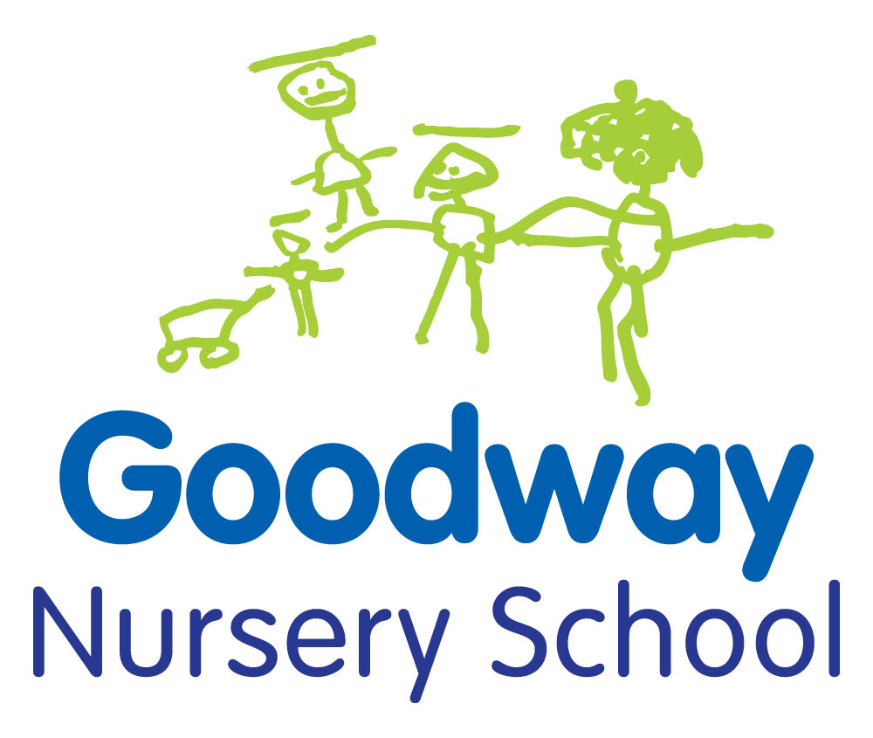

**Early Maths**

There are opportunities for children’s maths development everywhere

* In the home
* In the garden
* At the shops
* On the way to school
* At the park

**In the kitchen**

Bake and cook together

Weigh out ingredients

Point out the numbers on the scales

Talk about more and less

Talk about the size of pan or bowl

When eating ask who has got more and who has got less

Talk about how many plates you need

Talk about what shape the cake is

Talk about cutting toast in half or into quarters

Set the table together

Talk about how many cups etc you need

Set out 1 plate, 1 knife and fork and spoon for 1 person

Wash up together

Sort mugs, plates and cutlery when washing up

**Out and about**

Look at house numbers together

Point out numbers that are the same

Look at bus numbers

Look for significant numbers such as their age eg 3 or 4

Count yellow cars or red lorries

**Shopping**

Ask your child to help with the shopping and get 3 bananas etc

Ask your child to find the big packet or a small one

Point out whether things are the same or different

Ask your child if their bag is heavier or lighter than yours

Talk about how much it costs and sometimes let your child hand the money to the cashier

**Gardening**

Talk about how many seeds or bulbs you are planting

Talk about how tall the flowers are

Talk about “too long” or “too tall” when cutting bushes back.

 Ask whether the hole big enough for this plant

**Patterns and shapes in the environment**

Talk about shapes and patterns of everyday objects

Point out rectangular shapes of bricks in a wall

Point out diamond shapes in a trellis

Point out the round or triangular shapes of road signs

Look for all the circular shapes you can see eg wheels, road signs, traffic lights etc

**Bath time**

Use old plastic bottles, sieves, bowls and jugs in the bath

Talk about full & empty

Talk about more & less

Count toys and ducks

**In the home**

Count the steps as you go up or down the stairs

Talk about long or short hair as you brush it

Talk about big or small clothes as you hang them on the washing line

Count the socks etc on the washing line

**Songs & Rhymes**

Nursery rhymes and songs introduce counting

Baa, Baa, Black Sheep

1, 2, Buckle My Shoe

1 2 3 4 5 Once I Caught a Fish Alive

10 Fat Sausages Sizzling in the Pan…..

 5 Little Men in a Flying Saucer

5 Little Monkeys Jumping on the Bed

5 Little Speckled Frogs

5 Currant Buns in a Baker's Shop

.**Reading stories**

Talk about the sequence of events, what happens next?

Is this the beginning, middle or the end?

**Some books about numbers:**

Goldilocks and the Three Bears

The Three Billy Goats Gruff

The Three Little Pigs

One is a Snail, Ten is a Crab: a counting by feet book *by April Pully Sayre*

Handa’s Hen by Eileen Brown

 Ten Seeds *by Ruth Brown*

**Getting dressed**

Talk about clothes that are too big or too small

Talk about shapes, pattern and colour of clothes

Point out numerals on clothes

Sort pairs of socks, shoes and gloves

Count buttons on coats and cardigans