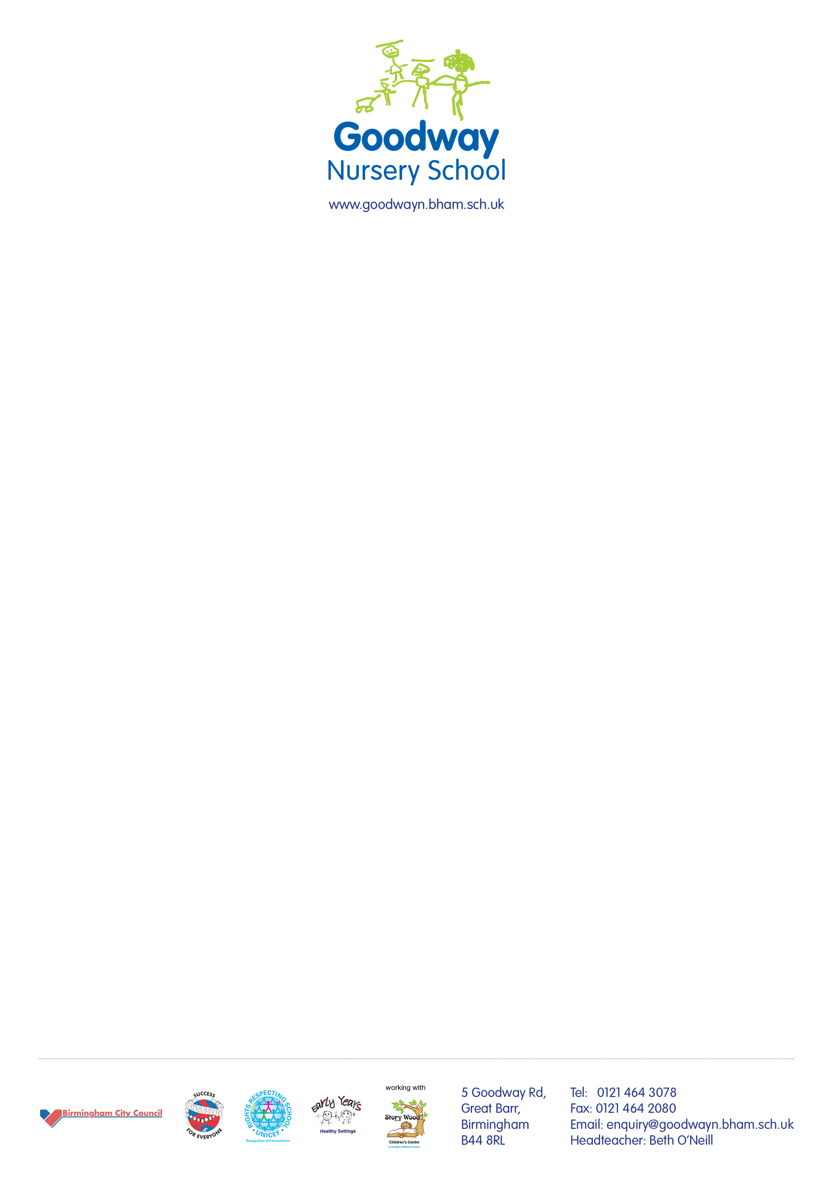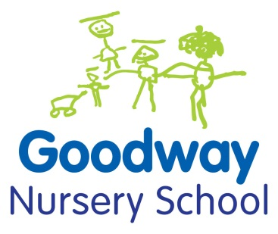

7th June 2018

Dear parents and carers,

I am really sorry but we have sent out the wrong information about the Father's Day celebrations in the newsletter.

The correct information is as follows:

**Poppies & Sunflowers** - Decorating biscuits:

* Tuesday 12th June at 8.45am
* Thursday 14th June at 8.45am

**Daisies** - Decorating biscuits:

* Friday 15th June at 11am
* Friday 15th June at 2pm

I apologise for any inconvenience this may cause,

Best wishes,

Beth